4.34: The ship would go a distance
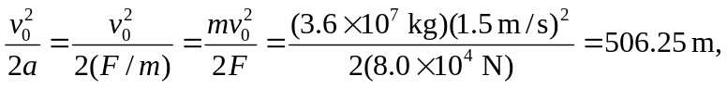
so the ship would hit the reef. The speed when the tanker hits the reef is also found from
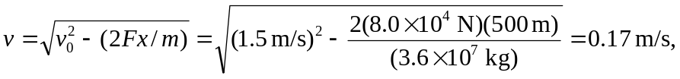
so the oil should be safe.

